Blockchain Based Online Voting Application

In this project we are employing Blockchain technology on Online Voting System as Blockchain has inbuilt support for data security and verification. Blockchain store each record as Block/Transaction and associate each record with unique hash code and while storing new record Blockchain will verify hash code of all previous blocks and if data not alter then it will result into same hash code and verification will be successful and if data tamper then it will result into different hash code and verification get failed.

Because of above advantages of Blockchain all applications are migrating to Blockchain server. So we are developing Online Voting system using Blockchain technology as the records stored in Blockchain cannot be tamper and support full integrity.

Blockchain can store and retrieve data using Smart Contract and this contract can be designed using Solidity programming and this contract contains functions which can be called from any programming languages to store and get data. We have designed following smart contract

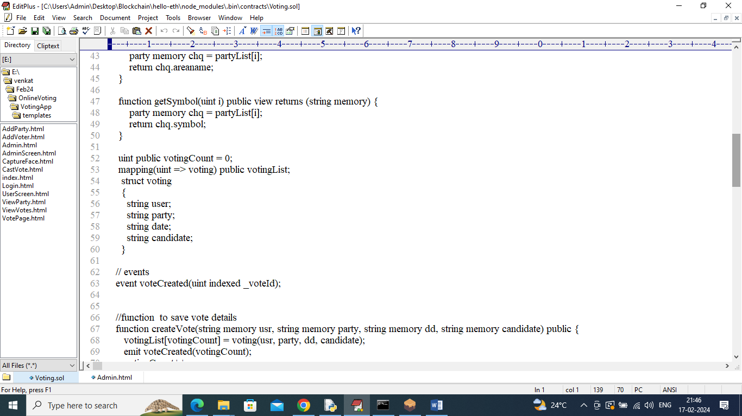

In above contract we have defined function to manage all Voting system like voter details, party details and user registration details. Now we need to deploy above contract in Blockchain Ethereum using below steps.

1. First go inside ‘hello-eth/node-modules/bin’ folder and then double click on ‘runBlockchain.bat’ file to get below screen
2. 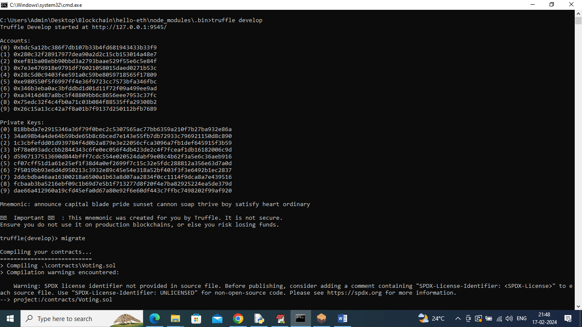
3. In above screen Blockchain started with default private keys and account and now type command as ‘migrate’ and press enter key to deploy contract and get below output
4. 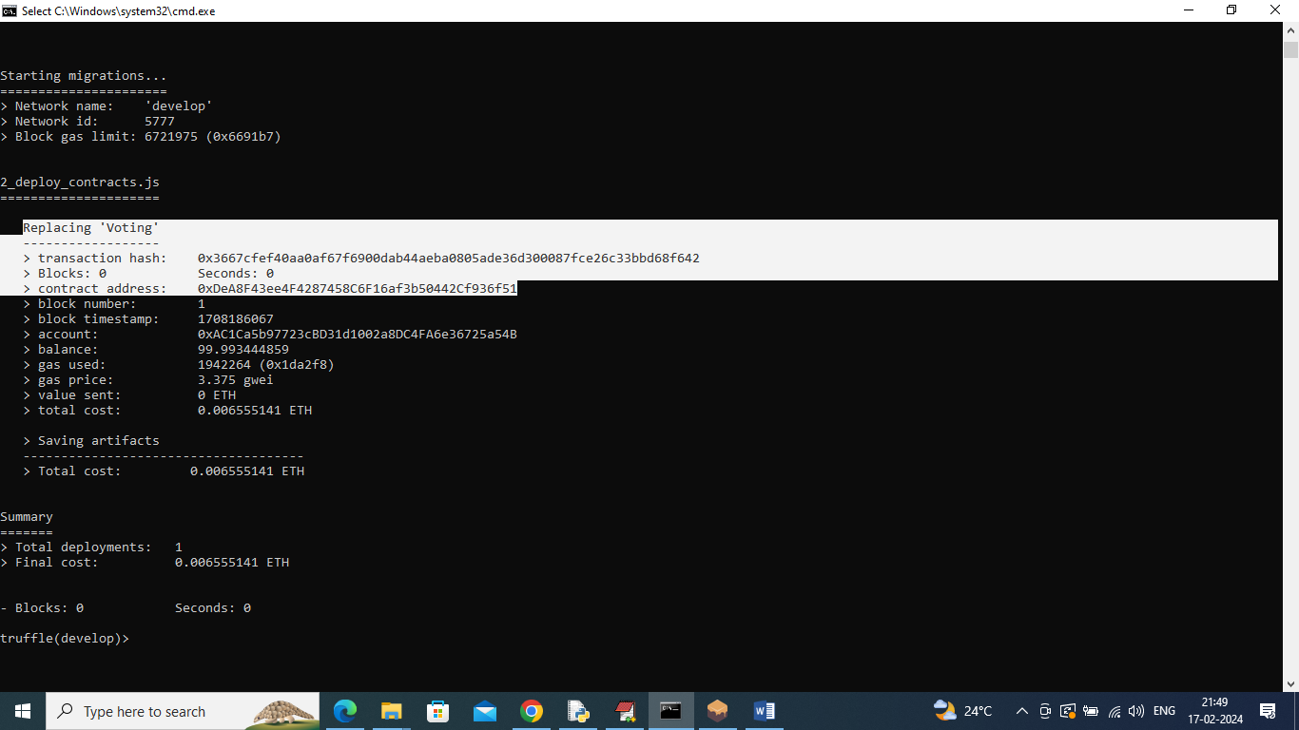
5. In above screen Voting contract deployed which can see in white colour text and got contract address also and this address need to specify in below python code to call functions from Blockchain
6. 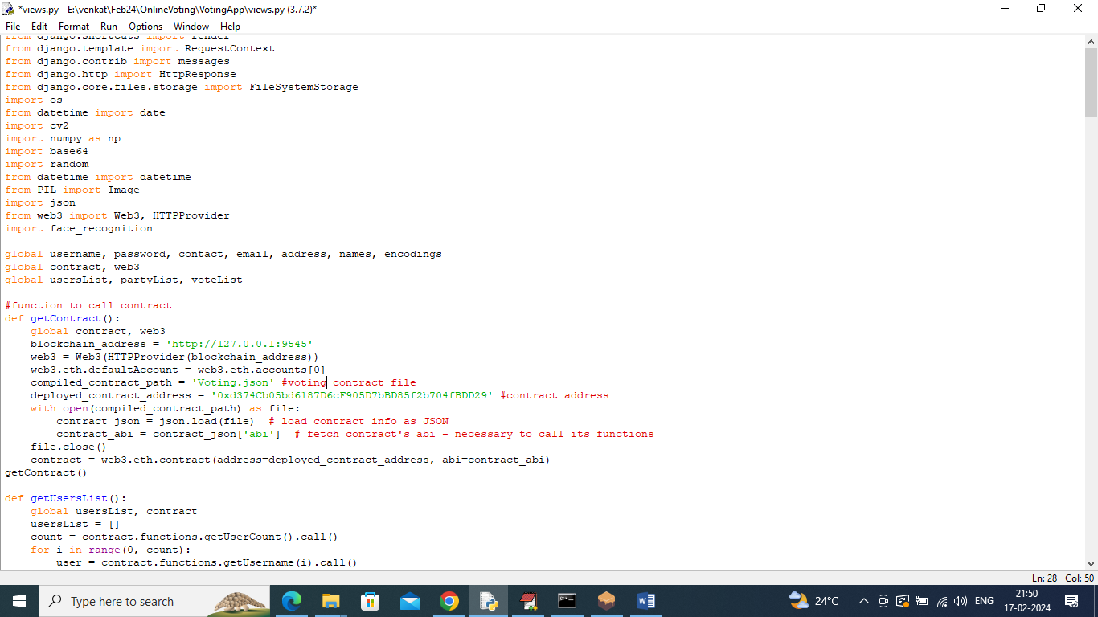
7. In above screen read red colour comments to know about contract calling and in above screens we saw contract deployed and running in Black console and let it run.

To implement this project we have designed following modules

1. Admin: admin can login to system using username and password as ‘admin’. After login admin will add party details, add voter details with faces and can view all party details and vote count
2. User: user can login to system by using login details provided by admin and then can ‘Verify face’, if face verified then only user will cast vote.

To run project double click on ‘run.bat’ file to start python web server and get below page

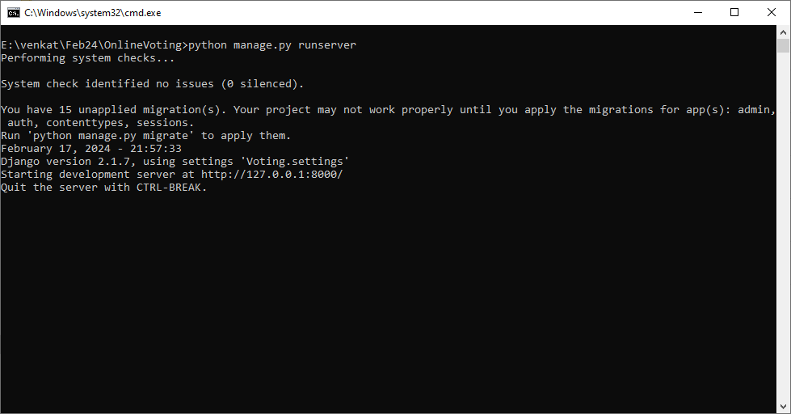

In above screen python server started and now open browser and enter URL as <http://127.0.0.1:8000/index.html> and press enter key to get below page

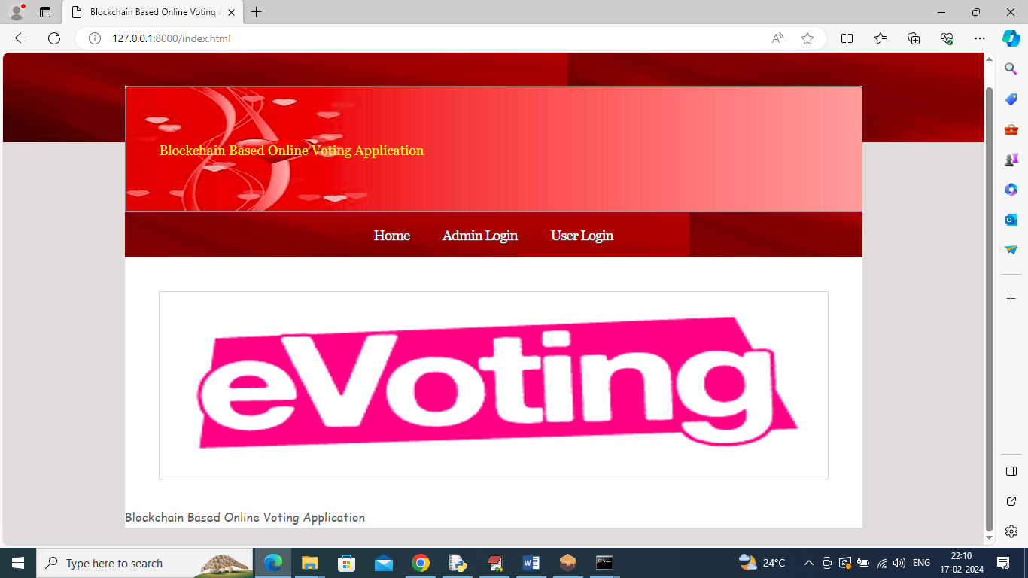

In above screen click on ‘Admin Login’ link to get below page

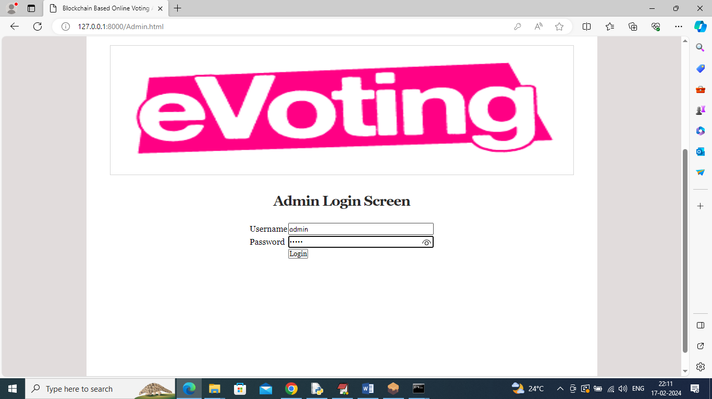

In above screen admin is login and after login will get below page

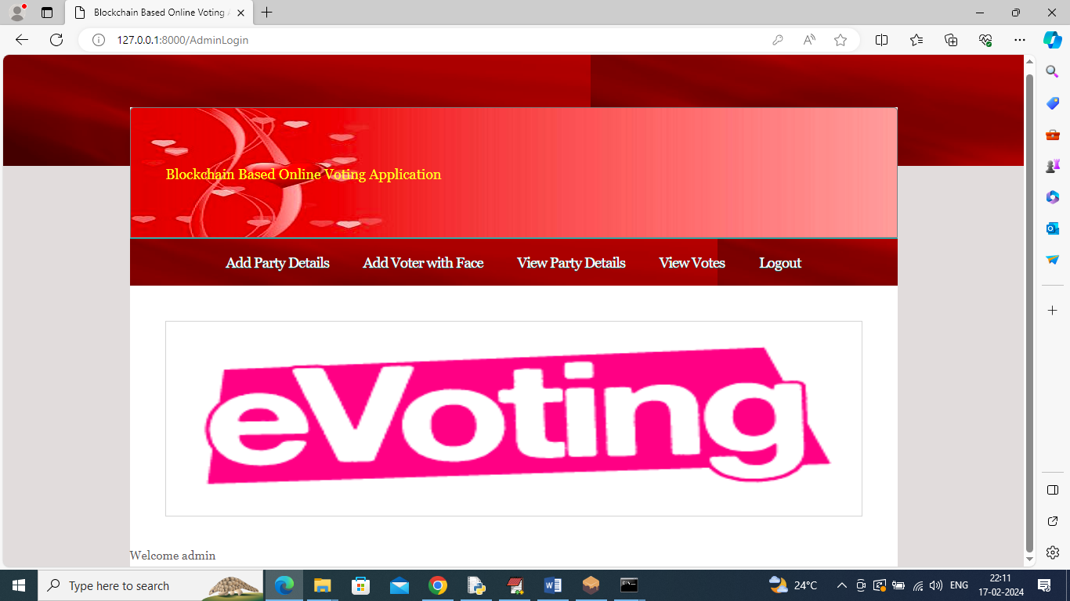

In above screen admin can click on ‘Add Party Details’ link to add party details

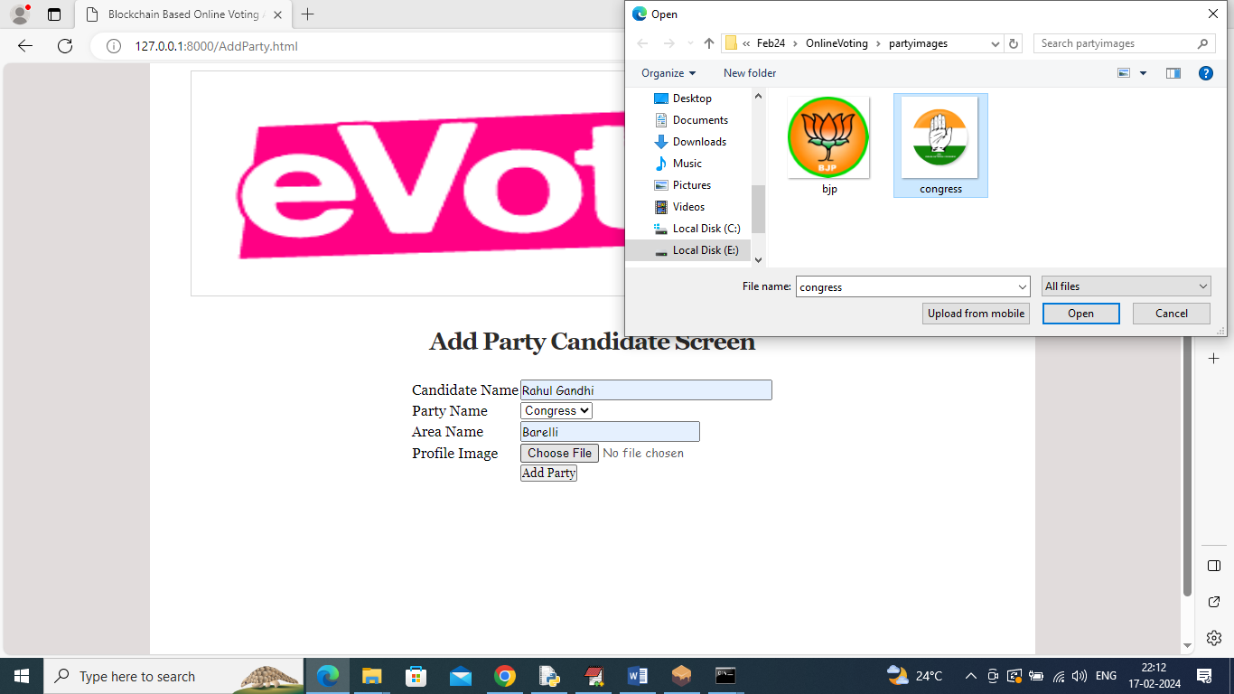

In above screen admin is adding party and candidate details along with symbol image and then click on ‘Add Party’ button to save details in Blockchain and get below output

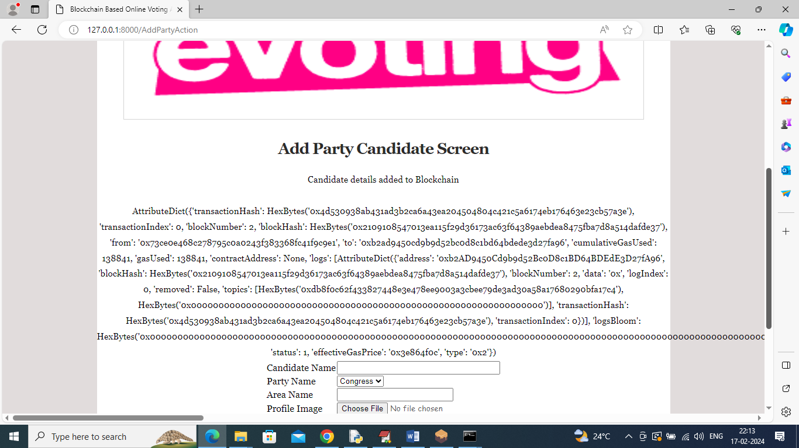

In above screen party details added to Blockchain and then displaying all output obtained from Blockchain and in above output can see Hash code, Block No and many other details and similarly you can add as many parties as u want

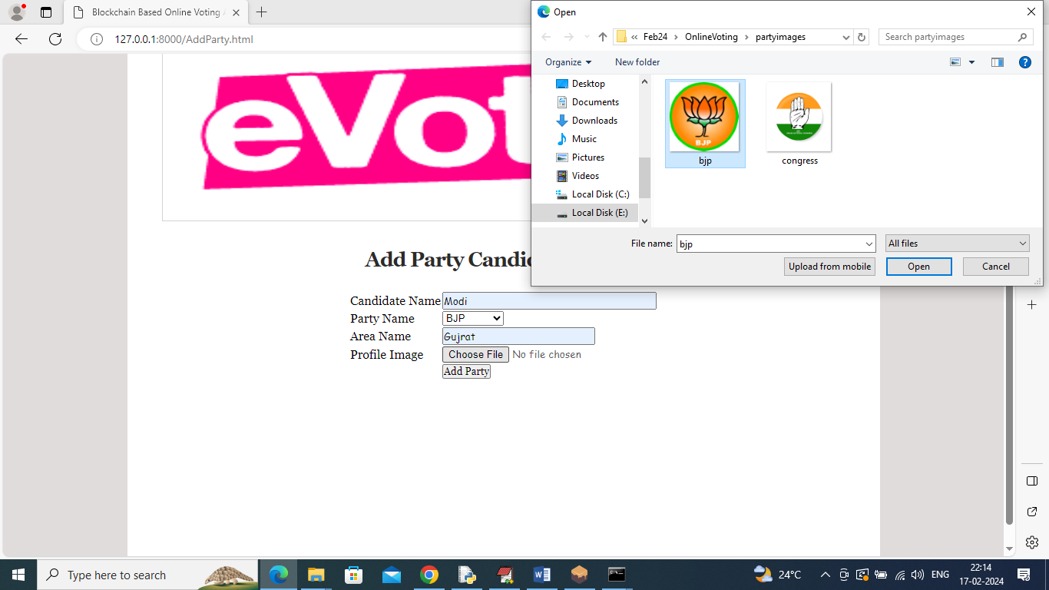

In above screen adding another party details and press button to get below page

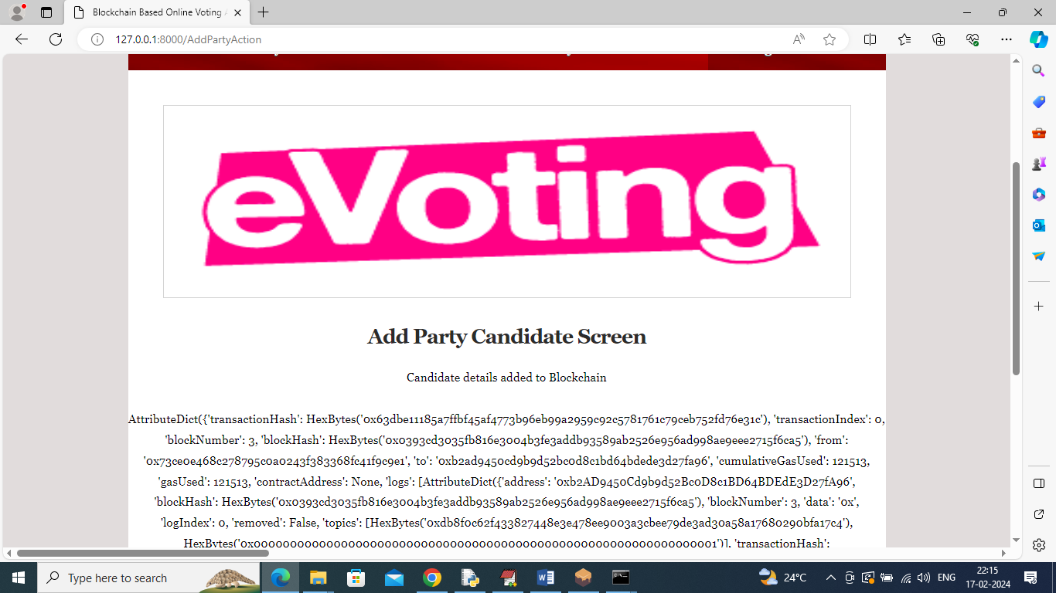

In above screen another party added and now click on ‘Add Voter with face’ link to get below page

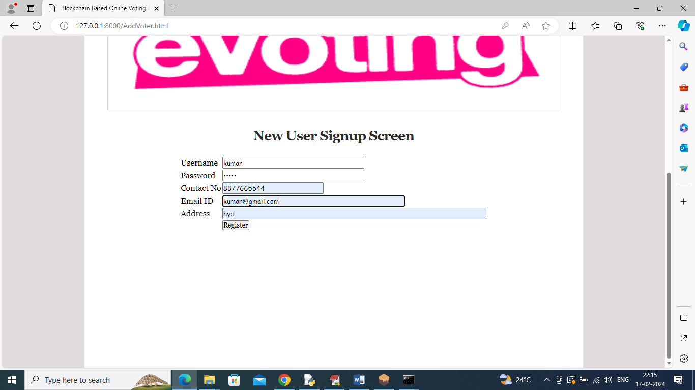

In above screen admin is adding new user details and then press button to get below webcam to capture face

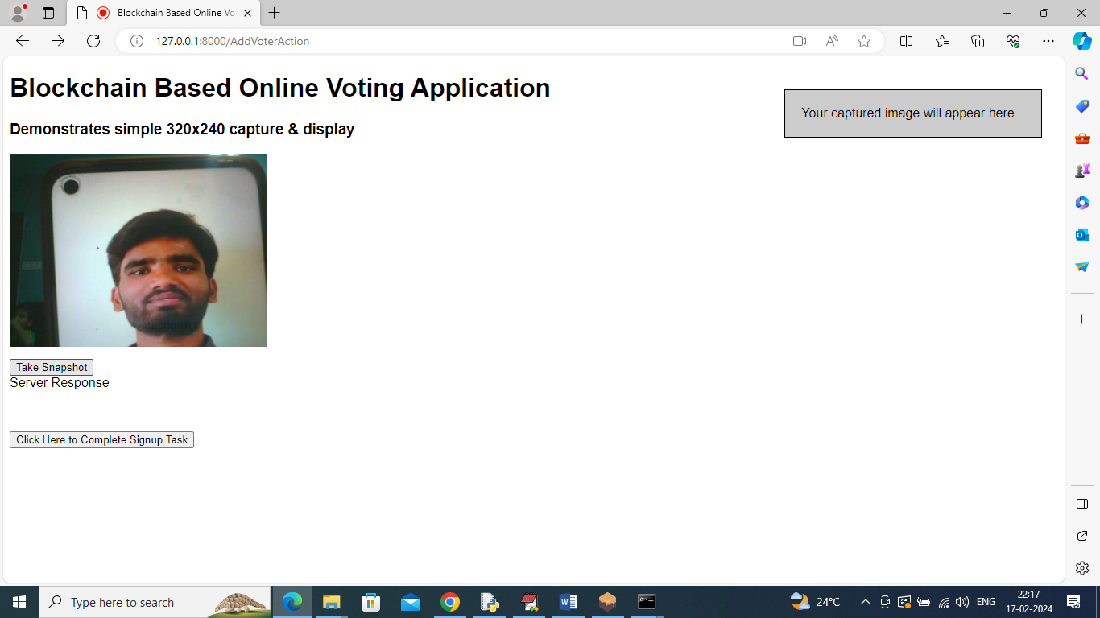

In above screen user can capture face from webcam and then click on ‘Take Snapshot’ button to capture face and get below page

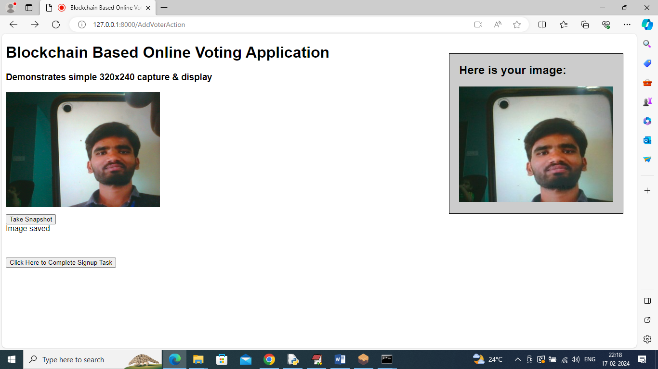

In above screen in Right side can see capture face and now click on ‘Click Here to Complete Signup Task’ button to save faces in Blockchain and get below page

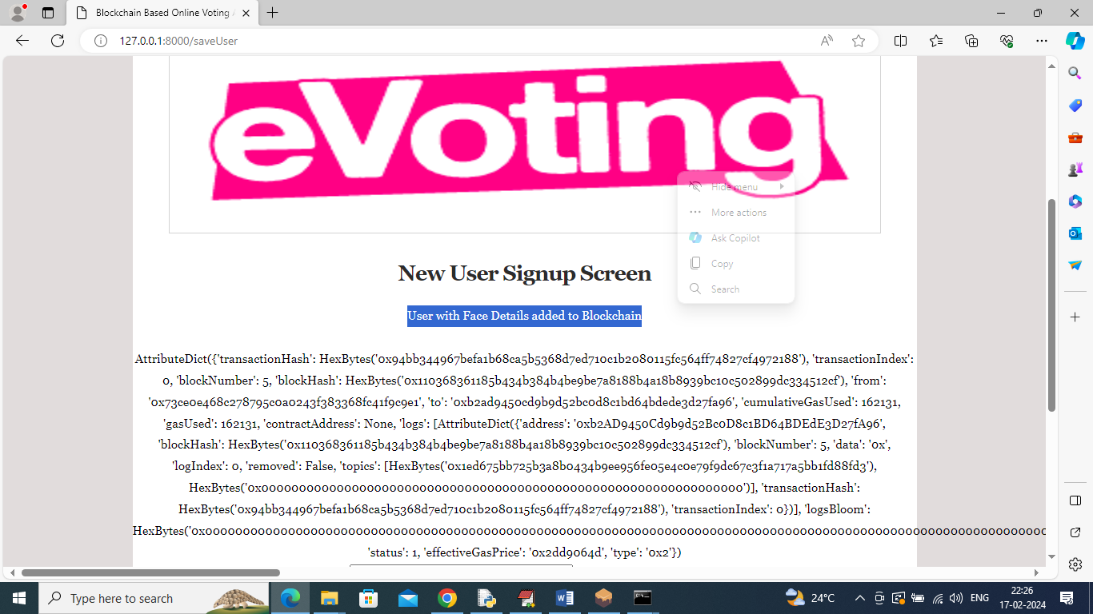

In above screen user with face details added to Blockchain and now click on ‘View Party Details’ link to get list of available parties from Blockchain

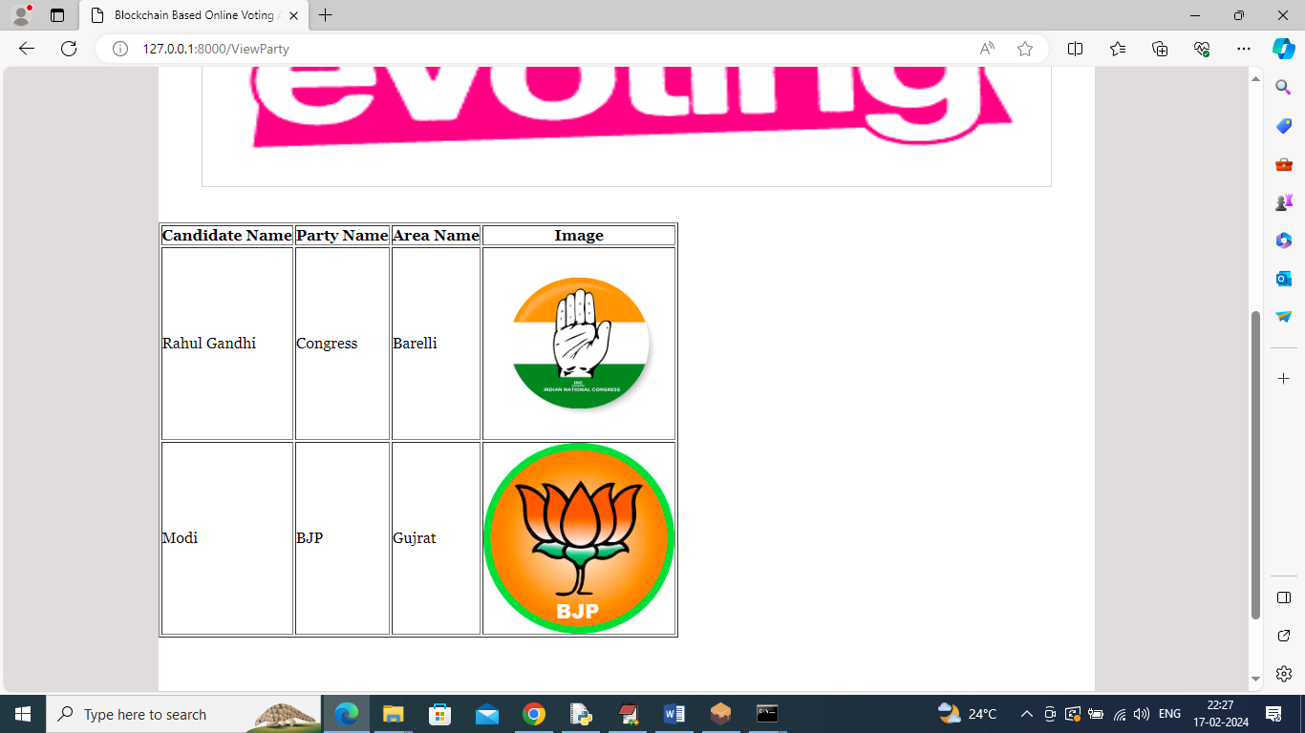

In above screen admin can view list of available parties and now logout and login as user to cast vote

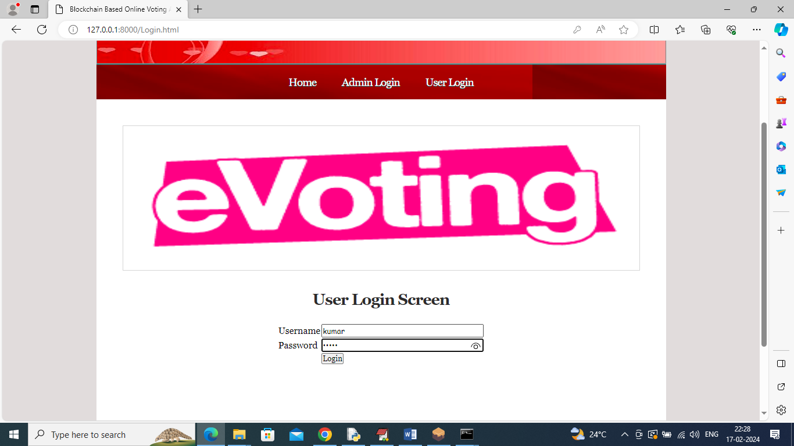

In above screen user is login and after login will get below page

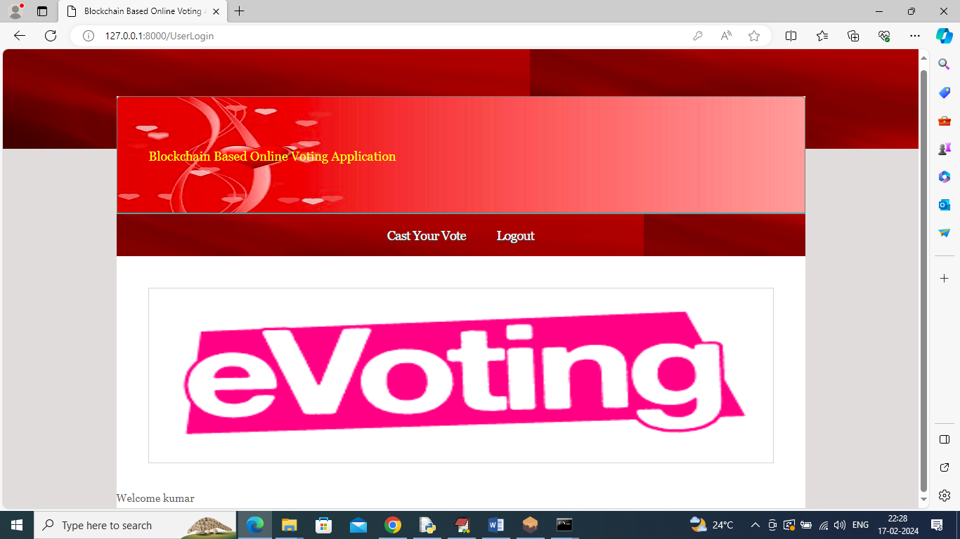

In above screen user can click on ‘Cast Your Vote’ link to verify face and then cast his vote

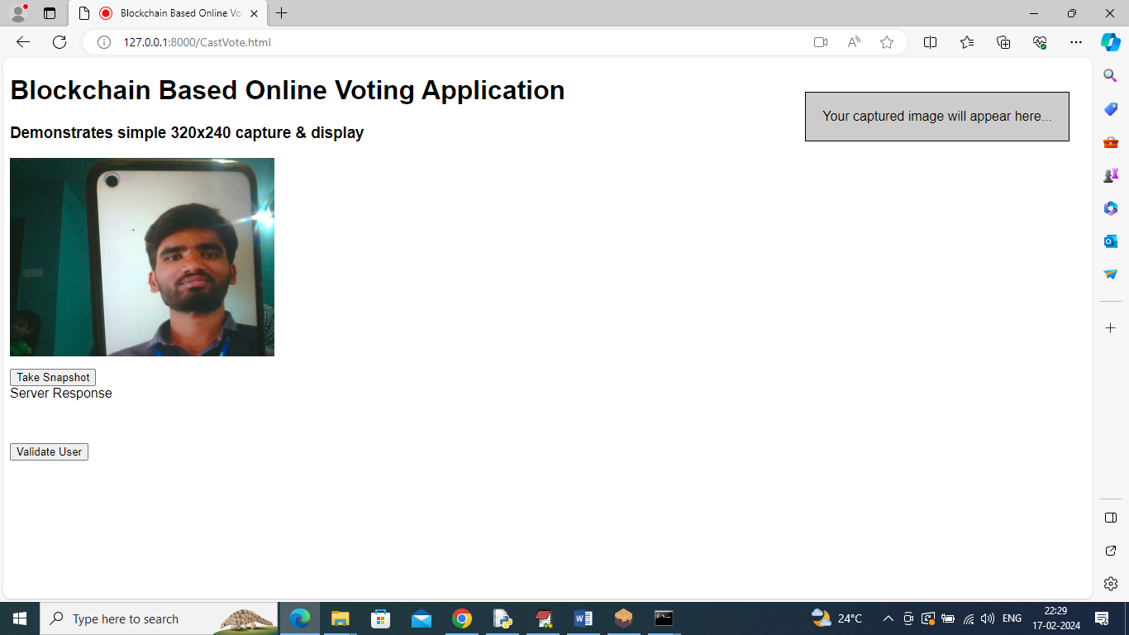

In above screen user can click on ‘Take Snapshot’ and then press ‘Validate User’ button to get below page

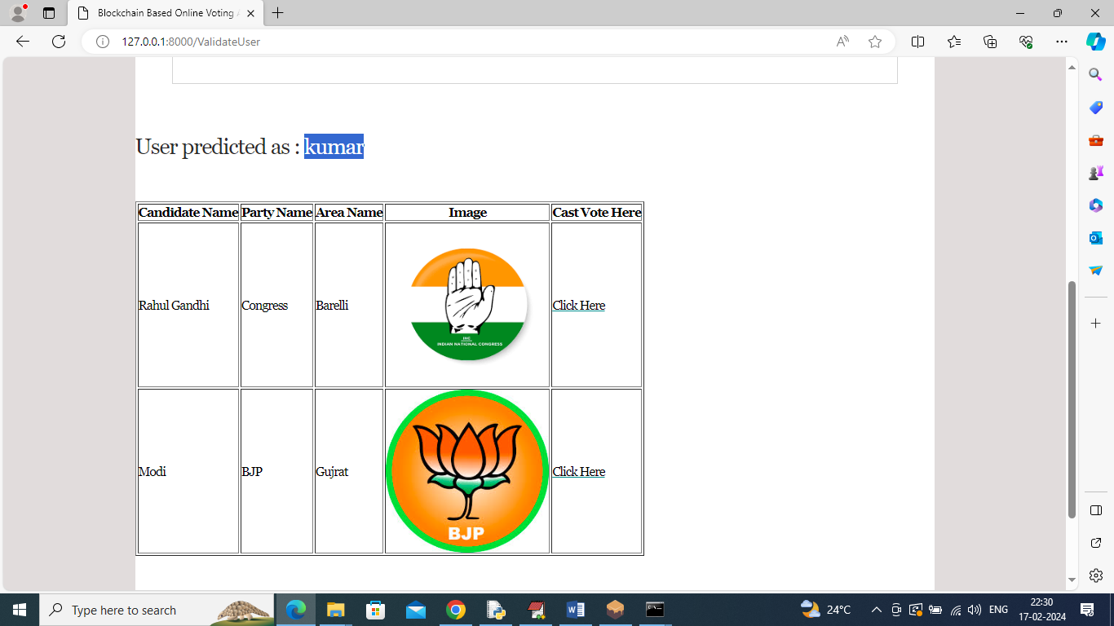

In above screen user face is validated as “kumar’ and now application will display him list of available parties and then user can click on ‘Click Here’ link beside desired party symbol to cast his vote and get below output

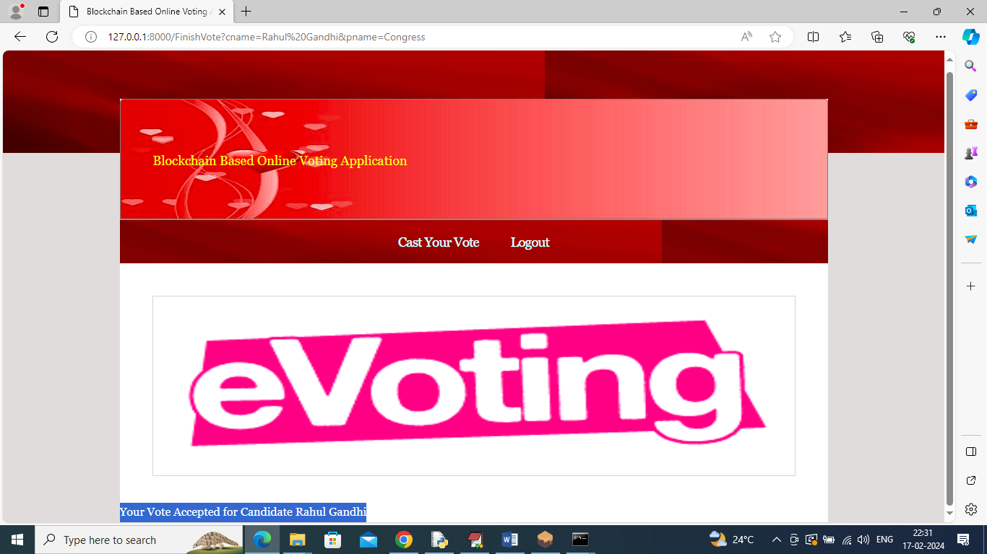

In above screen user can view casted vote in blue colour text and now logout and login as admin to view vote count

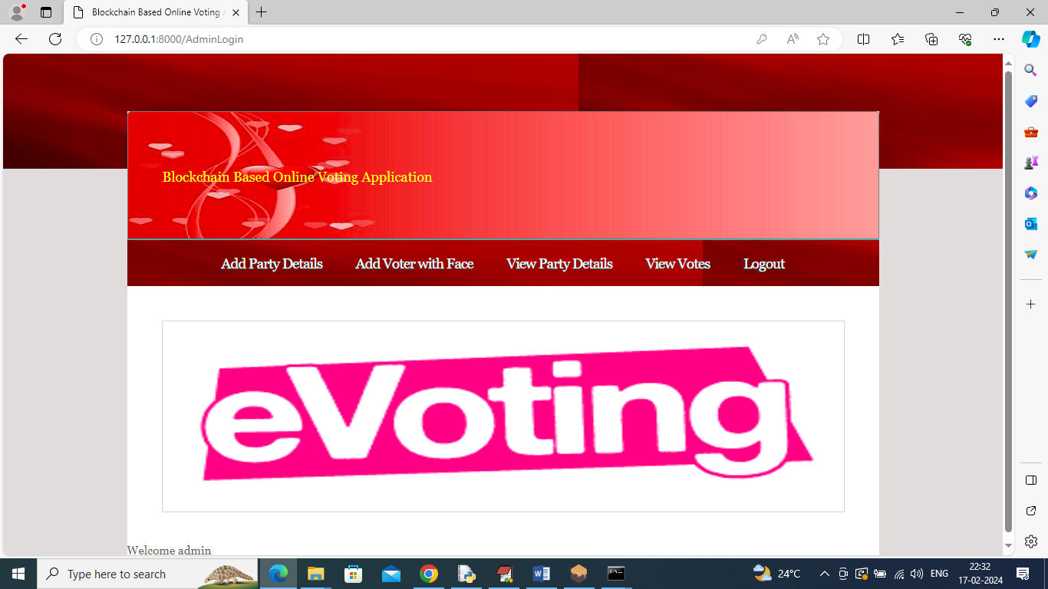

In above screen admin can click on ‘View Votes’ link to get below output

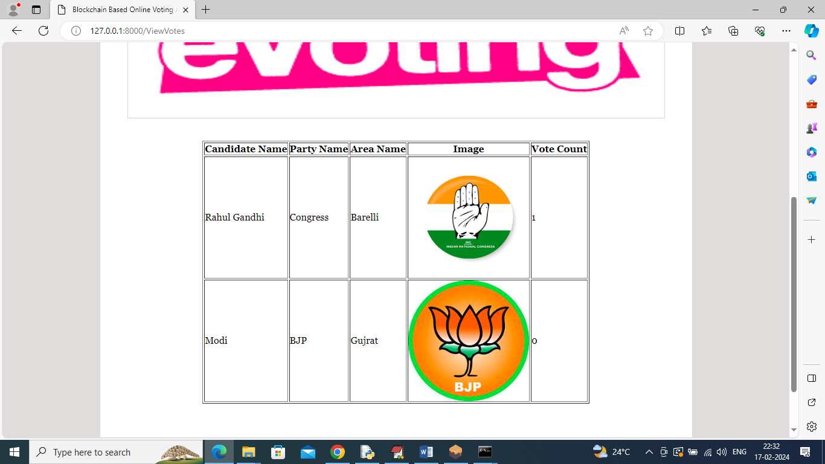

In above screen in last column we can see vote count of each party and similarly by following above screens you can manage all voting details in Blockchain.

All voting transactions you can see in GANACHE also like below screen

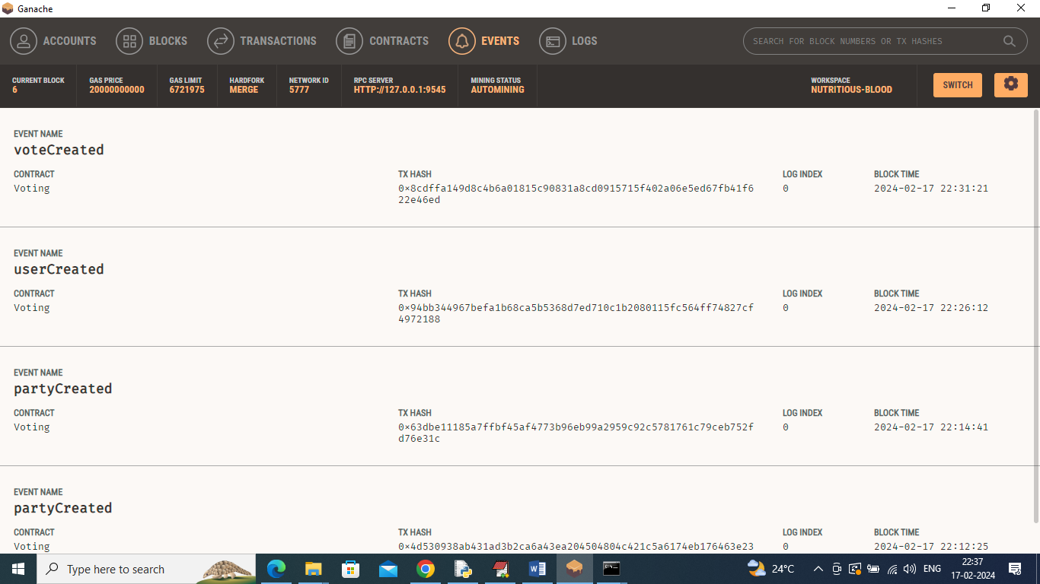

In above ganache screen you can see created events for voting application.